**Superior University Reiwend Road**

Name: Haseeb Arshad

Roll no: SU92–BSSEM-F22-177

Section:5D

Subject: CN Lab  
Task 4

Submitted to: Sir Rasikh Ali

**Design the network of "Lab-7" or “Lab-8” (2-3 rows of computers) Use: Server, Switch, Router, & End-Devices like Laptop/PC Assign them IP Address (Dynamically/DHCP) of any Network (or you can use network 192.168.1.0)**

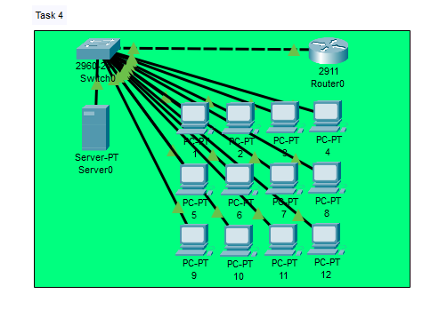

**Router Configuration Command:**

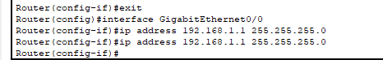

**DHCP Server Configuration:**

